**Parks and allotments questionnaire**

**Easy read**

Newcastle has some great parks, allotments and green spaces.

Parks and allotments in Newcastle are looked after by Urban Green Newcastle. They look after 33 parks and 60 allotments.

We want to find out what you think about the parks and allotments in Newcastle, and what we should do to look after them in the future.

Please tick the boxes or write your answer in the box. Each question will tell you how many boxes you can tick.

**What do you think about the parks in Newcastle?**

1. Please tell us how often you go to a park in Newcastle.

Please tick **one** box.

Every day

Once a week

Once a month

Less often

Never

If you said less often or never, please tell us why here.

**2. What is important to you about the parks in Newcastle? Please tick up to **three** boxes from the next two pages.

I can get out and enjoy green spaces.

I like art, music or festivals in the parks.

I can go through the park to get to somewhere else.

I like parks because they are good for the environment.

I like parks because they are free to use.

Parks are good for my mental

health.

Parks are good for my physical health.

I like the history of the parks.

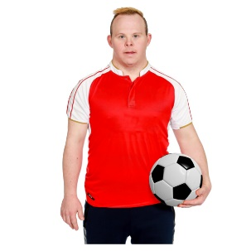

I can play sport or keep fit in the parks.

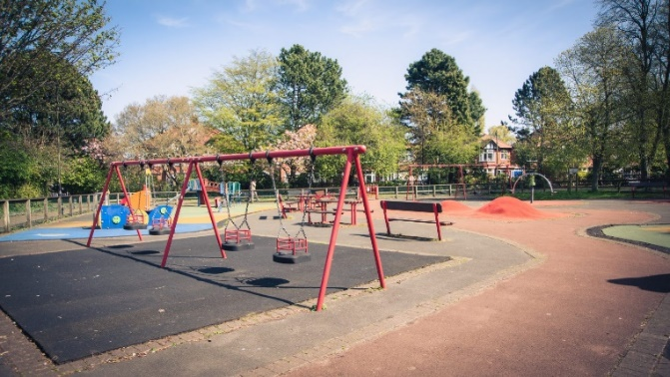Children and teenagers can play on equipment in the parks.

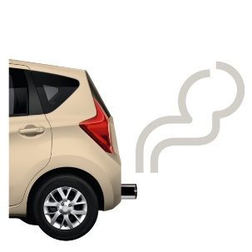

There is no traffic in the parks.

Parks are good for plants and animals.

If there is anything else that is important to you about the parks in Newcastle, please tell us here.

**3. Please tell us how you get to a park.

Tick **one** box.

I walk or **wheel**.

**Wheel** means using a wheelchair, mobility scooter or walking frame with wheels.

I use the bus.

I use the metro.

I go by car or van.

I go on my bike.

Please tell us if you use any other way to get to a park in Newcastle.

4. Please tell us the name of your favourite park in Newcastle.

5. Please tell us the names of any other parks that you like to go to in Newcastle.

**What do you think about the allotments in Newcastle?**

6. Do you have an allotment?

Tick **one** box on this page.

Yes, I have an allotment.

Please tell us where your allotment is.

No, I do not have an allotment, but I am on a waiting list for one.

No, I do not have an allotment, but I used to have one.

No, I do not have an allotment, but I sometimes visit them to help a friend or for another reason.

No, I have never had an allotment and I do not ever visit one.

from the next two pages.

I can get out and enjoy green spaces.

Allotments are good for the environment.

You can grow food on

allotments.

Allotmentsare good for my

mental health.

Allotments are good for my

physical health.

You can meet new people at allotments.

**There is no traffic on an allotment.

Allotments are good for plants and animals.

If there is anything else that is important to you about the allotments in Newcastle, please tell us here.

**The future of parks, allotments and green spaces in Newcastle.**

It costs a lot of money to look after parks, allotments and green spaces.

8. Please tell us whatyou think we should do to make sure we manage parks, allotments and green spaces well.

9. If there is anything else you want to tell us about parks, allotments and green spaces in Newcastle please tell us here.

Please help us to know more about you on the next pages. You can ask someone to help you do this.

Thank you for answering our questions.

We will tell you what people said later this year. You can find out here <https://www.letstalknewcastle.co.uk/> and our website: [www.newcastle.gov.uk](http://www.newcastle.gov.uk).

Easy read made by the Easy Info Team at Skills for People, employing people with a learning disability.

**Please answer these questions about you.**

You can ask someone to help you fill this part in.

**Please write your postcode here:**

|  |
| --- |
|  |

**Please tell us who you are:** (tick one box)

|  |  |
| --- | --- |
| A resident |  |
| A Councillor |  |
| A business owner |  |
| Someone from a voluntary or community organisation |  |
| Other, please say here: |  |

**Do you have a disability, a long standing illness or infirmity?** (tick one box)

Long standing means anything that has affected you for a long time or will affect you for a long time in the future.

|  |  |
| --- | --- |
| Yes |  |
| No |  |
| Prefer not to say |  |

**Are you:** (tick one box)

|  |  |
| --- | --- |
| Male |  |
| Female |  |
| Prefer not to say |  |
| Other or prefer to describe, please tell us here: |  |

**How old are you?** (tick one box)

|  |  |
| --- | --- |
| Under 18 |  |
| 18-24 |  |
| 25-34 |  |
| 45-54 |  |
| 35-44 |  |
| 55-64 |  |
| 65-74 |  |
| 75 and over |  |
| Prefer not to say |  |

**What is your ethnicity?** (tick one box)

|  |  |
| --- | --- |
| Asian or Asian British |  |
| Black or Black British |  |
| Chinese |  |
| Mixed or multiple ethnic groups |  |
| White or White British |  |
| Prefer not to say |  |
| Other, please say here: |  |